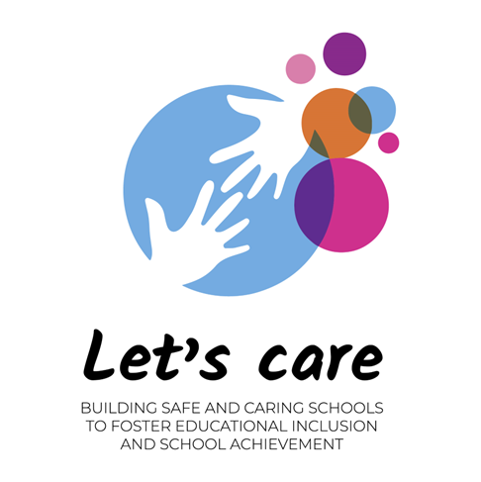

**Participatory Action Research[1] (PAR)** is collaborative research, education and action used to gather information to use for change on social or environmental issues. It involves people who are concerned about or affected by an issue taking a leading role in producing and using knowledge about it. Many names are now used to describe research processes that are in some way ‘participatory’: e.g. Participatory Appraisal, Participatory Learning and Action, Community-Based Participatory Research.

The Participatory action research (PAR) methodology is conceived within the LET'S CARE project as a cross-cutting tool, which is taken up from the very beginning of the project (WP1, Task 1.1), but it will be an action that will have repercussions on all the projects affecting the 4 Pillars (Safe learning, Safe teaching, Safe schools and safe education)

The objective of the LET'S CARE PAR Toolkit is to provide guidance on how to introduce the PAR approach transversally in the different actions of the project as well as to raise the questions that we will have to ask ourselves throughout the development of the project.

PAR is a research approach, not a method. Many different methods can be used in PAR projects, as in the case of LET'S CARE: focus groups, semi-structured in-depth interviews, life stories, storytelling, photo elicitation, etc.

As explained above, the PAR approach should be oriented to these **actions**:

1. PARTICIPATORY
   1. Collaboration throught participation
   2. Empowerment of participants
2. ACTION
   1. Change-real life experience
   2. Evidenced in terms of different outcomes
3. RESEARCH
   1. New Knowledge
   2. Documentd lessons

PAR asks reflexive questions about whose ‘voice’ matters in the research process through methodological innovation and infusing community expertise with academic tools and research methods[2]. The level of involvement of research participants varies according to context, aims and project resources. That said, PAR studies share several underlying assumptions:

* Formal education is not necessary to take part in valuable research.
* Those who have lived experience of an issue or system are experts and therefore are best placed to contribute to related research.
* Involvement of non-academics in research design and production can improve research by reducing biases and bringing new insights and perspectives[3].

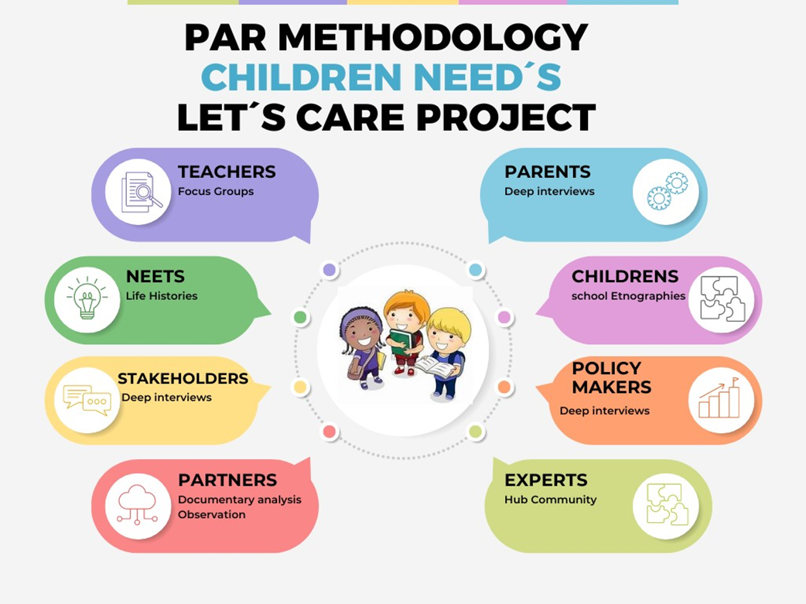

Figure 1. PAR Methodology: Children Need´s Let´s Care Project

1. Pain,R., Whitman, G. and Milledge, D. (Durham University)& Lune Rivers Trust (2010-2011). Participatory Action Participatory Action Research Toolkit: An Introduction to Using PAR as an Approach to Learning, Research and Action
2. Kindon, S., Pain, R. and Kesby, M. (2009) 'Participatory Action Research', in Kitchin, R. and Thrift, N. (eds.) International Encyclopedia of Human Geography. Oxford: Elsevier, pp. 90-95
3. Organizing Engagement, (2021). Participatory Action Research and Evaluation.